Smart Home Automation System Using Arduino Cloud, Alexa, Relay, and Gas Sensor

Abstract
This project presents a smart home automation system that allows the user to control home appliances using Alexa voice commands and the Arduino Cloud web platform. A relay module is used to switch the light ON and OFF remotely. The system also monitors home weather conditions using a temperature and humidity sensor and detects LPG gas leakage using a gas sensor. When gas leakage is detected, an alert is generated for safety. This project combines IoT, cloud communication, voice control, and sensor-based monitoring in one integrated system. It is low cost, practical, and useful for modern smart homes.
Introduction
Home automation is becoming an important part of modern life because it makes daily tasks easier, safer, and more convenient. In a smart home, appliances can be controlled automatically or remotely using internet-connected devices. This project is designed to control a light using a relay, check weather conditions, detect LPG gas leakage, and operate the system using Alexa voice commands through the Arduino Cloud web interface.
This project is useful because it reduces manual work and improves safety. For example, the user can turn lights ON or OFF without touching a switch, check room weather data from the cloud, and receive alerts if dangerous gas is detected. Such systems are widely used in smart buildings, IoT-based homes, and automation applications.
Objective of the Project
The main objectives of this project are:
- To control a light using a relay module.
- To monitor home weather conditions using sensors.
- To detect LPG gas leakage and generate an alert.
- To use Alexa voice commands for appliance control.
- To connect the system with Arduino Cloud web for remote monitoring.
- To develop a smart and safe home automation model.
Components Used
Component | Quantity | Description
ESP32 / Arduino board | 1 | Main controller for IoT communication
Relay module | 1 | Used to control the light
Light bulb / LED | 1 | Output load
DHT11 / DHT22 sensor | 1 | Measures temperature and humidity
LDR Sensor
MQ2 gas sensor | 1 | Detects LPG gas leakage
Buzzer | 1 | Gives alarm during gas leakage
BUCK CONVERTER | 1 | Convert 12V to 5V
Jumper wires | Required | Used for connections
Breadboard | 1 | Used for circuit setup
Wi-Fi connection | 1 | Needed for cloud and Alexa integration
Li-ion Battery Power source | 1 | To power all components and ESP32

Pin Connection
Component | ESP32 Pin | Component Pin | Purpose
DHT11 Sensor | GPIO 4 | DATA | Temperature & Humidity
MQ2 Gas Sensor | GPIO 35 | AO (Analog Out) | Gas value reading
Buzzer | GPIO 12 | +ve | Alarm output
LED / Relay IN | GPIO 14 | IN / +ve | Control light
LDR Sensor | GPIO 34 | DO (Digital Out) | Detect darkness
GND | GND | All component GND | Common ground
5V / VIN | VIN (5V) | VCC of modules | Power supply

Device | Connection
Li-ion Battery | Input of Buck Converter
Buck Converter Output 5V | ESP32 VIN
Buck Converter GND | ESP32 GND
All others VCC and GND is connected as per circuit diagram or 3.3V and GND.
Circuit Diagram
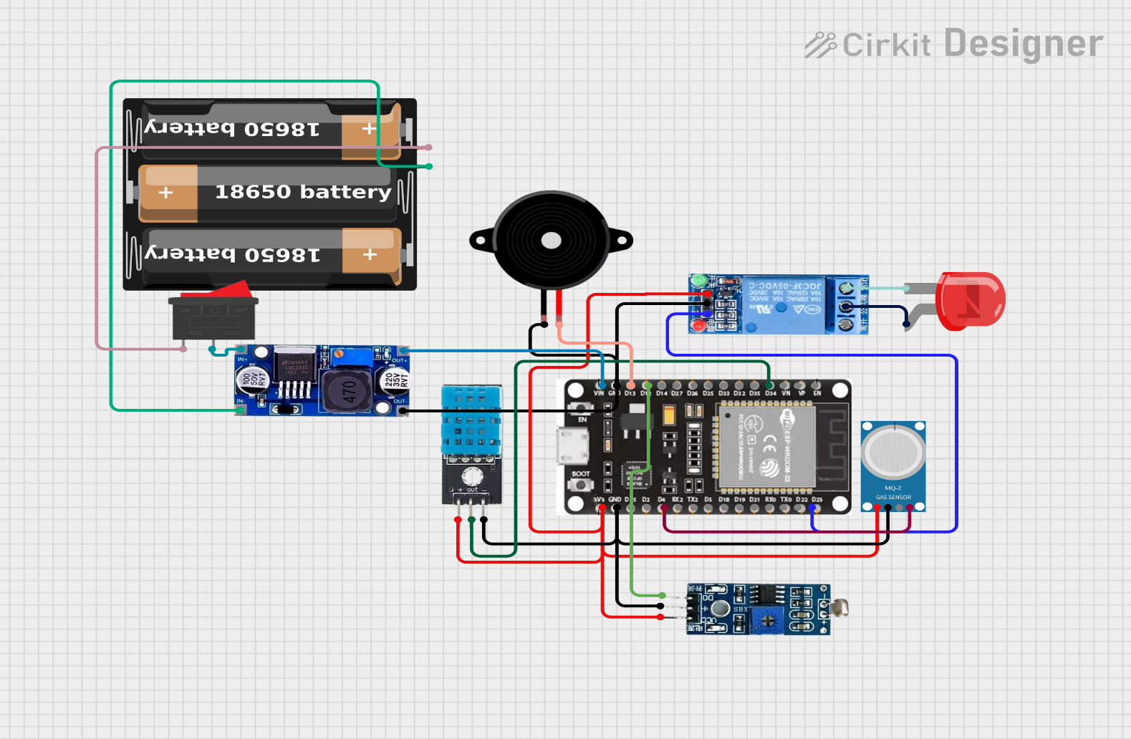

Working Principle
The smart home system works by connecting sensors and output devices to a microcontroller with Wi-Fi support. The microcontroller communicates with Arduino Cloud and Alexa over the internet.
When the user gives a voice command to Alexa, the command is sent to the cloud and then transferred to the microcontroller. The microcontroller processes the command and controls the relay to turn the light ON or OFF. The DHT sensor continuously measures temperature and humidity, and the values can be viewed on the Arduino Cloud dashboard. The MQ2 gas sensor monitors the presence of LPG gas. If gas concentration becomes higher than the safe level, the buzzer sounds and an alert can be shown on the cloud dashboard.
This makes the system useful for both comfort and safety in a smart home environment.

Algorithm / Program Logic
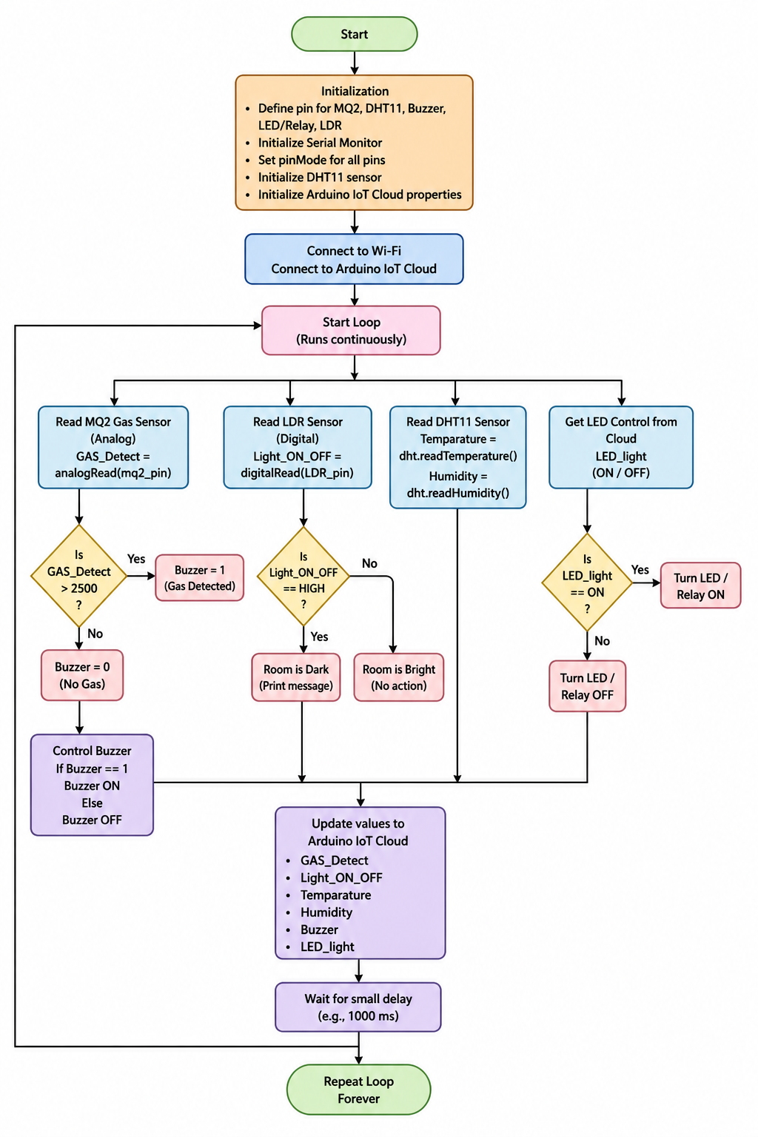
Code
GitHub Link :- https://github.com/suman1eight9ece24-svg

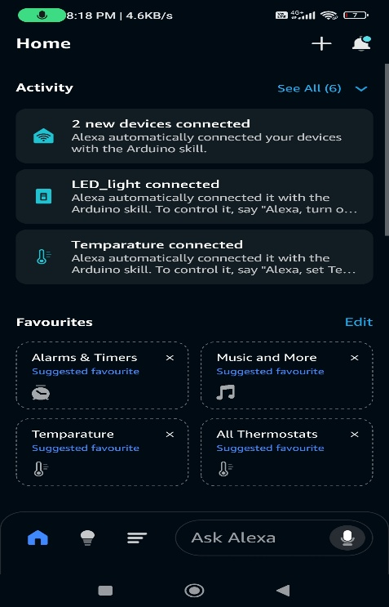
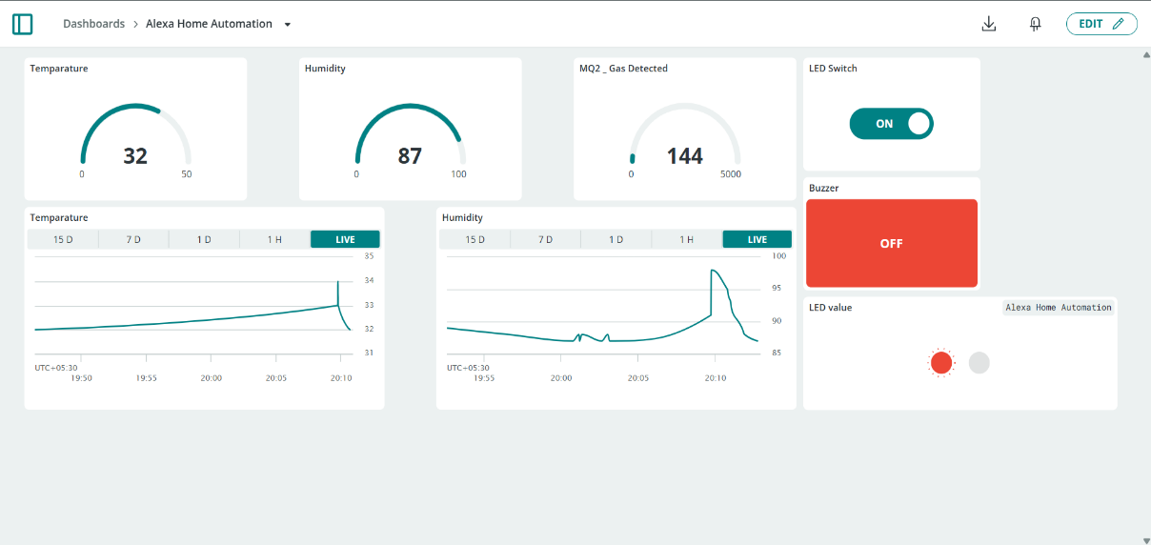
Results :-

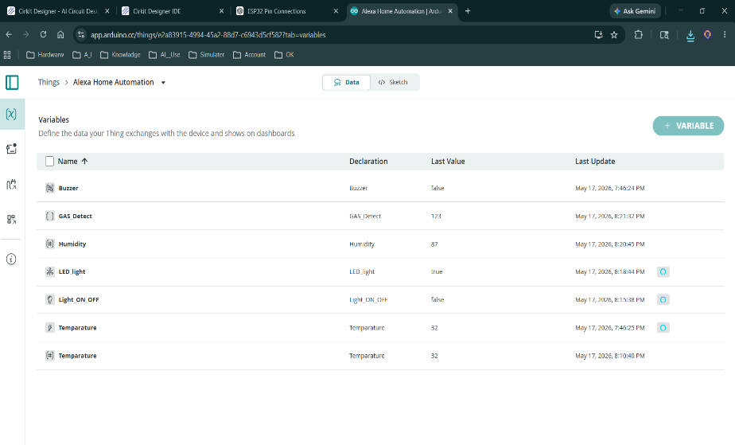
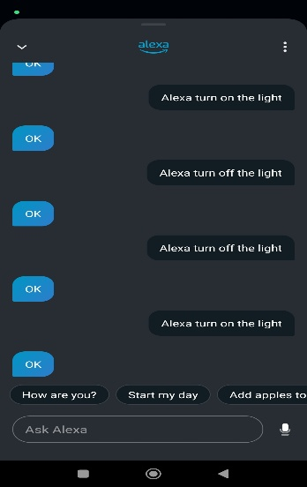
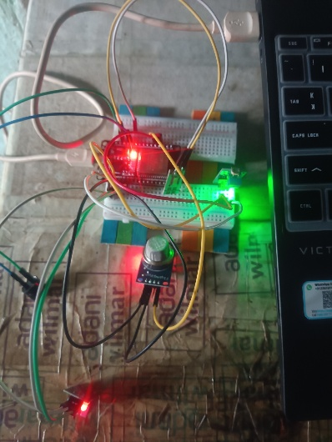

Applications
This project can be used in many real-life applications such as:
- Smart homes
- Home safety systems
- IoT-based automation systems
- Remote appliance control
- Gas leakage warning systems
- Smart energy management
- Home weather monitoring
Future Improvements
The project can be improved further by adding:
- Multiple relays to control fan, TV, and other appliances
- Mobile app control along with Alexa
- Automatic light control using motion sensors
- Fire or smoke detection sensors
- LCD or OLED display for local status monitoring
- Notifications to mobile phone during gas leakage
- Energy monitoring for smart power management
Conclusion
The smart home automation system successfully combines relay-based appliance control, weather monitoring, gas leakage detection, Alexa voice control, and Arduino Cloud web connectivity. It improves comfort, safety, and convenience in home management. The project is cost-effective, practical, and suitable for modern IoT-based smart home applications. It also provides a strong learning platform for embedded systems, cloud IoT, and home automation technology.

